

Project Proposal



VolCom

Building community of volunteer

Sajjad Alam | K16-3412 | MS (SPM) Project

**Supervised by**

**Engr. Abdul Rahman Mahmood**

Asst. Professor at FAST NUCES

Contents

INTRODUCTION AND BACKGROUND 2

PROBLEM STATEMENT 2

PREVIOUS WORK 2

PROJECT DESCRIPTION 3

FUNCTIONAL SPECIFICATION 3

FUNCTIONS PERFORMED 3

LIMITTIONS AND RESTRICTIONS 3

OTHER FEATURES 4

USER INTERFACE DESIGN 4

DESIGN SPECIFICATIONS 5

SYSTEM DESIGN 5

SOFTWARE 6

HARDWARE 6

IMPLEMENTATION DETAIL 7

IMPLEMENTATION PLAN 7

DELIVERABLE ITEM 7

MILESTONE DESCRIPTION 8

REFERENCES 9

# INTRODUCTION AND BACKGROUND

In social media age, every details regarding to our problem as a society is highlighted very quickly and everyone raise voices for the resolution. Our society is full of problems that are created by us and the need to be addressed more than ever now. Problem like littering, green environmental issues and awareness issues etc. As a Karachites, we have huge number of population and if energy that lies inside it, channelized properly, can create huge difference. We have seen young generation waste most of their time sitting, chatting drinking teas etc.

With time, issues are piling up and organization like fixit comes forth whose ideology is to self-help rings my thought to build an app which can connect such people who want to give back to society

## PROBLEM STATEMENT

“To build an android application to provide a social platform using mobile devices from which issues related to vicinity, awareness drive, protest can be raised and build a team to solve those issues voluntarily in a most simplistic way, in other words build community of volunteers and give power to individuals who are always willing to execute for betterment of society.”

## PREVIOUS WORK

There are very few organizations that are running their volunteering services but not everybody is connected to them and they are supervised by their own policies and limitations. There are few local groups also that try to solve issues by their own as well single person initiatives also popup on media now and then. How technology can help these groups and individuals is what this project is trying to address. Most of the open source work related to this project is web based and not according to our local problems. Some paid apps are also available but they are to be brought by organization who offer their services such as “Make a wish” and “The Citizen’s Foundation”. Some apps are only doing volunteer managements for individuals similar to task management. Application related to problem statements are

GiveGap: Its IOS based app which is a fundraising platform built for nonprofit organizations. Major features are Volunteering Management, Campaign Management, and Donations Collection

Give Today: Its android, US only based application which is donation centric volunteering features

Kiwanis: Its fairly complex app with huge set of features and US based

There are few more similar platforms like Volunteer App and My Selfless Act. These apps either used by organizations to manage their volunteering services or individuals to manage their volunteer works. Facebook events can also be used to solve such need but it lacks volunteering functions. Gaps that I found in available apps is that they are location specific or web based, and organization controlled, used commercially and complex for our needs. Some apps do fairly simple thing like collecting issue details and sending it to authorities to take actions.

# PROJECT DESCRIPTION

The vision behind this project is to let our people fix issues created by us, lack of governance etc. and to promote self-volunteerism in one own capacity without relying on other forces. The aim of the project named “VolCom” is to develop an android based application that shall enable group of people or individual to raise local issues, share them on social media, connect with each other, fix them collectively or escalate them to concern authorities. This project promote an idea of teams and to build community of volunteers. Since self-initiative is the core driving factor of this application, Gamification and social media sharing will help build continuous interest. People who cannot participate, can donated for the raised event.

## FUNCTIONAL SPECIFICATION

### FUNCTIONS PERFORMED

* **Profile module**

This module represents the profile of the user and has following high level functions

* + Create/Update
  + Manage and monitor selected events
  + Reviews and feedback
  + Track your services
* **Team module**

Team module is a set of user profiles joins as a team to perform particular tasks

* + Manage teams – create, delete, join or unjoin
* **Local Issue module**

This module contains issue details that need to be raised by the user

* + Create, escalate, status management
* **Events module**

This module is built to cater event functionality. Events are objects that is created against any reported issue and it can only be created as a member of a team

* + Create and manage
  + Participation
  + Share it on Social media
  + Send it to mobile Contact list
  + Track and monitor
  + Donate for an event
  + Ratings and feedback
* **Time line Module**

This is the main splash screen module of the app where all the happening inside application can be viewed by the user. It’s the most simplistic version of Facebook news feed.

### LIMITTIONS AND RESTRICTIONS

* Since this application will perform its major functions over the internet, internet connection is necessary.
* This Application will be developed for Android only.
* Only Facebook social media will be considered
* Payment and donation will be build according to availability but system will be built to be able to connect
* The scope of this project does not involve complying with any standards, operating framework or protocols.

### OTHER FEATURES

* In App Chat Module

Through this module, teams can communicate each other and maintain communication for the record what happened during an event.

* Team, User and Event Ratings
* Event search

### USER INTERFACE DESIGN

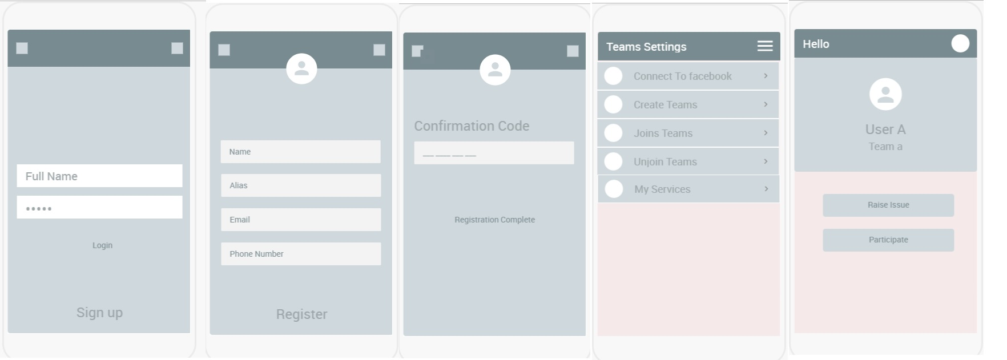



Fig. 1 High level User Interfaces

## DESIGN SPECIFICATIONS

### SYSTEM DESIGN

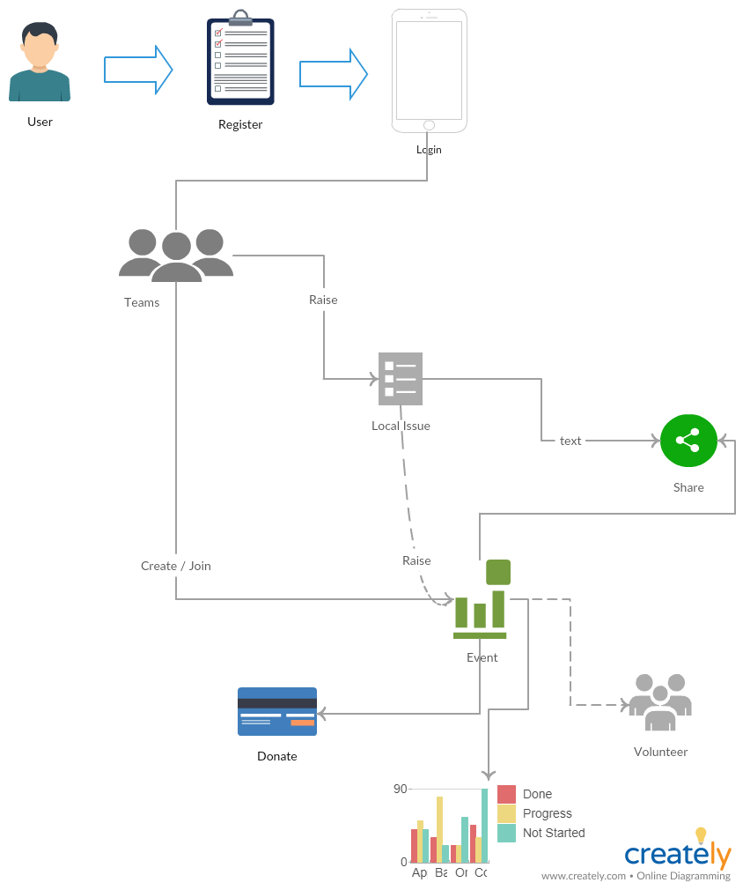

Fig . 2 High level Flow Diagram

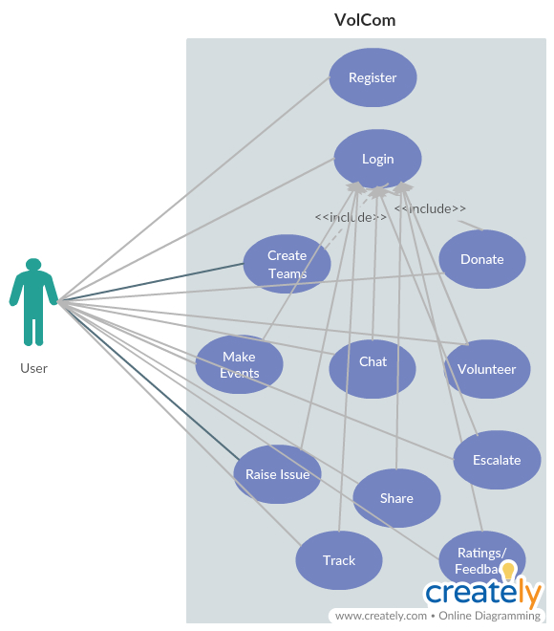

Fig . 3 Usecase Diagram

This use case diagram depicts the user and the system interaction during the application usage

### SOFTWARE

* Android Studio
* Apache database MySQL
* Node Rest service API
* Google map API
* Facebook sharing API
* Payment Gateway

### HARDWARE

* Android Device
* Service application server and Database server

## IMPLEMENTATION DETAIL

This project will be based upon andiron mobile application. The application will for main functionalities such as creating issue, raising issue against the issue, sharing to social media, monitoring and in app messaging. To build this app, minimum dependencies is focused to remain architecture simple and cost reduced.

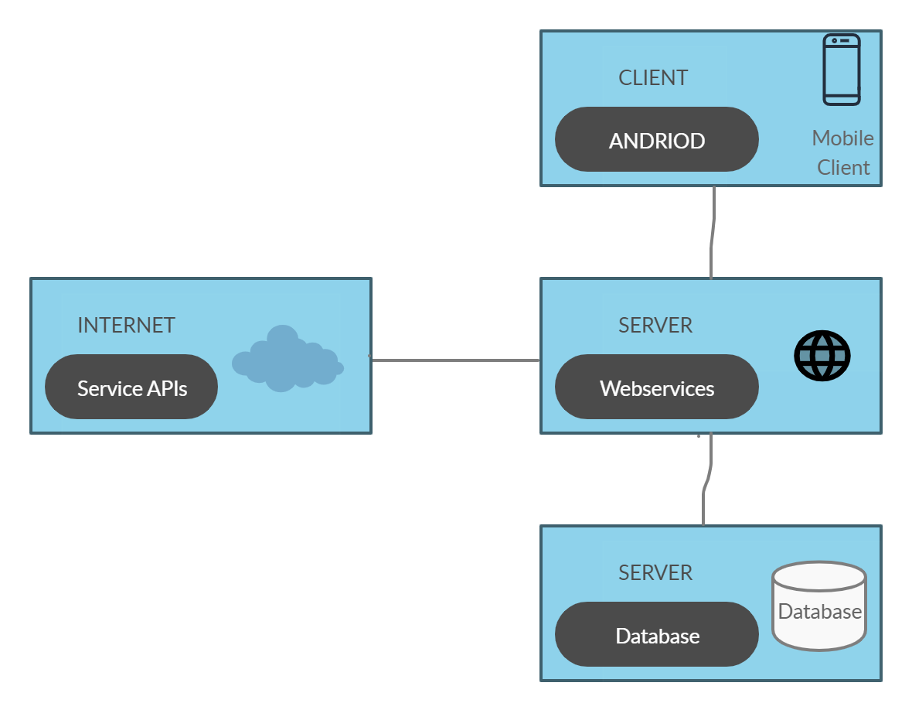

Fig. Architecture Diagram

## IMPLEMENTATION PLAN

### DELIVERABLE ITEM

* Android executable APK file
* Source code of the application
* Project report and other documentation.

### MILESTONE DESCRIPTION

|  |  |  |
| --- | --- | --- |
| Name | Start | Due |
| VolCom App: | | |
| Consent form | 21/08/2019 | 22/08/2019 |
| Topic discussion | 08/08/2019 | 18/08/2019 |
| Research on ideas | 18/08/2019 | 28/08/2019 |
| Preparation of project proposal | 01/09/2019 | 10/09/2019 |
| Changes in proposal report | 12/09/2019 | 20/09/2019 |
| Presentation preparation | 22/09/2019 | 24/09/2019 |
| Proposal Submission | 22/09/2019 | 22/09/2019 |
| Proposal defence | 24/09/2019 | 02/10/2019 |
| Requirement gathering | 02/09/2019 | 15/10/2019 |
| Research for proposed app | 15/11/2019 | 21/11/2019 |
| Database structure designing | 21/10/2019 | 1/11/2019 |
| UI Designing | 1/11/2019 | 1/12/2019 |
| Development | 1/12/2019 | 20/12/2019 |
| Final report preparation | 21/12/2019 | 31/12/2019 |

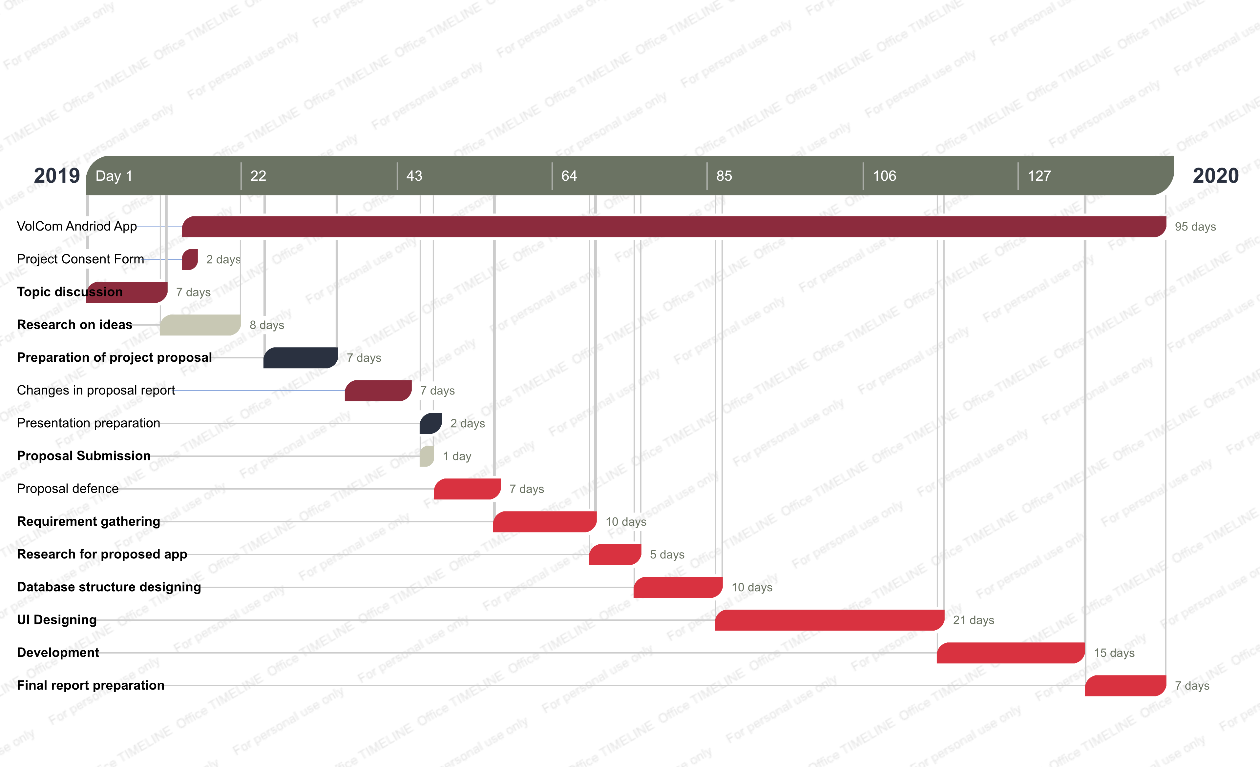

# REFERENCES

[1] “Volunteerism — letting our youth fix Pakistan,” *dawn*. [Online]. Available: <https://www.dawn.com/news/1161476>.

[2] The spirit of volunteerism. [Online]. Available: <https://tribune.com.pk/story/461074/the-spirit-of-volunteerism/>.

[3] <https://www.volunteermatch.org/>.

[4] Volunteering and its Surprising Benefits [Online]. Available: <https://www.helpguide.org/articles/healthy-living/volunteering-and-its-surprising-benefits.htm>.

[5] *The Self-Directed Volunteer – with Susan j. Ellis*. [Online]. Available: <https://www.energizeinc.com/hot-topics/2010/may>.

[6] <https://www.givegab.com/>